PRACTICAL 11
Part A (To be referred by students)

Object Oriented Programming, Class Object, self, __init__, instance variables and methods
SAVE THE FILE AND UPLOAD AS (RollNo_Name_Exp11)
Aim: To implement Object Oriented Programming Concept in Python

Problem Statement:
Apply core and object oriented Python concepts to build following applications

- Create a Vehicle class without any variables and methods.
- Create a class with instance attributes
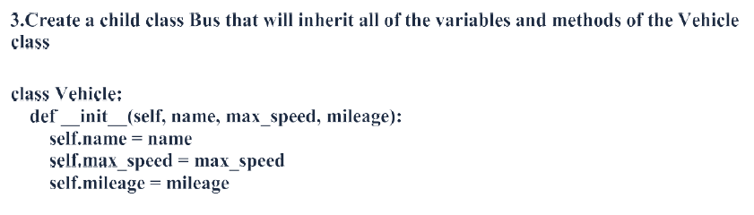
Write a Python program to to create a Vehicle class with max_speed and mileage instance attributes

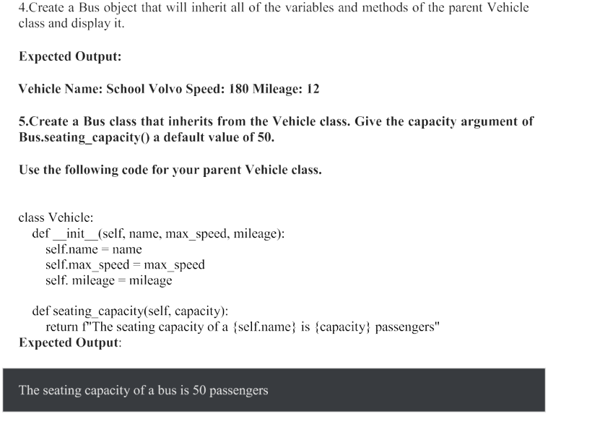
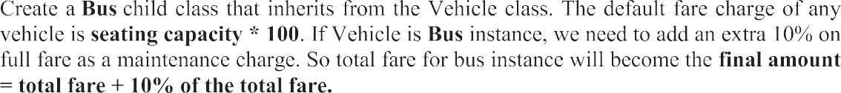

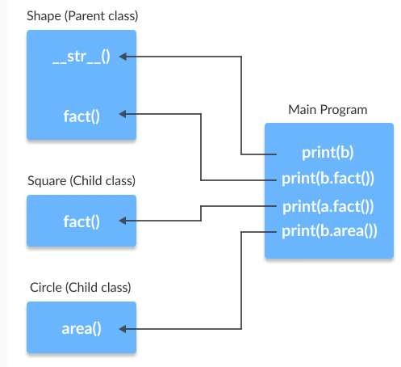

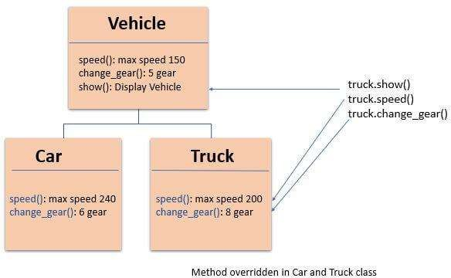

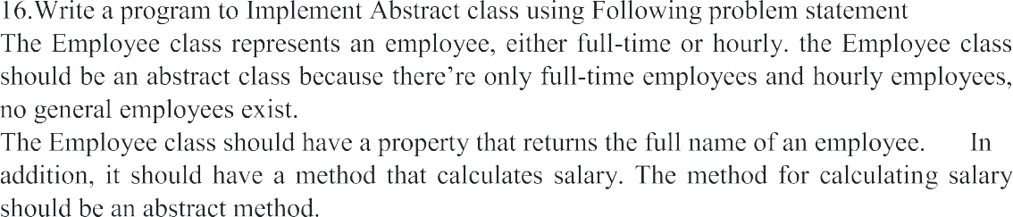
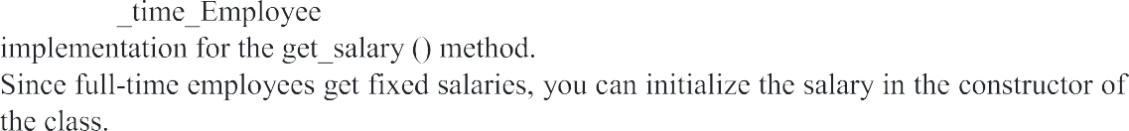
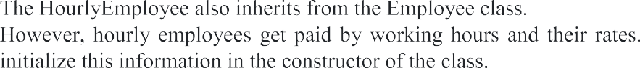

Topic covered: Object Oriented Programming, Class, Object, Instance Method, Instance Variables etc.

Learning Objective: Learner would be able to
- Understand the OOP concepts in Python
- Apply OOP to Solve real world applications

Theory:
Program to show use of class and Objects…
class Student(object):
def __init__(self): # constructor
self.name='Aditya'
self.age=30
self.marks=900

def talk(self):
print("Name:- ", self.name)
print("Age:- ", self.age)
print("Marks:-",self.marks)

obj=Student()
print(obj.name)
print(obj.age)
print(obj.marks)
obj.talk()

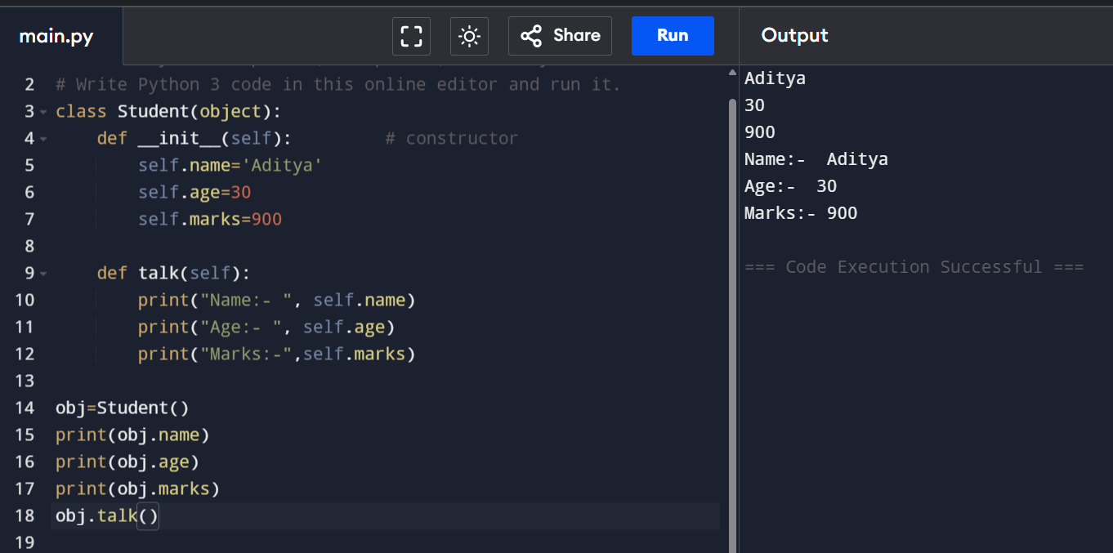

self Variable:-
- self is a default variable that contains the memory address of the instance of current class.
- so, we can use 'self' to refer to all instance variable and methods.
- Self is used as first parameter in constructor as
  - def __init__(self): --> in this case self is used to indicate instance variable of class
- self can be used as first parameter in the instance methods as:
  - def talk(self):
  - here, talk is instance method as it act on instance variable.

Constructor:-
- Used to initialize instance variables.
- In constructor we can create instance variable and initialize them with some value.
- The first parameter of constructor is self-variable that contains the memory address of the instance.
- Example:-

def __init__(self): # constructor
self.name='Aditya'

- Here, constructor have only one parameter and name is instance variable.
- A constructor is called when we create an instance as:
- S1=Student()
- In, Student ( ), empty parenthesis represents we are not passing any values to constructor.
- Self is passed implicitly…

Constructor with Parameters:-
class Student(object):

def __init__(self,n='',m=0,a=0): # constructor with default arg.
self.name=n
self.marks=m
self.age=a

def talk(self):
print("Name:- ", self.name)
print("Age:- ", self.age)
print("Marks:-",self.marks)

obj1=Student()
obj1.talk()
obj2=Student("Yash",600,21)
obj2.talk()

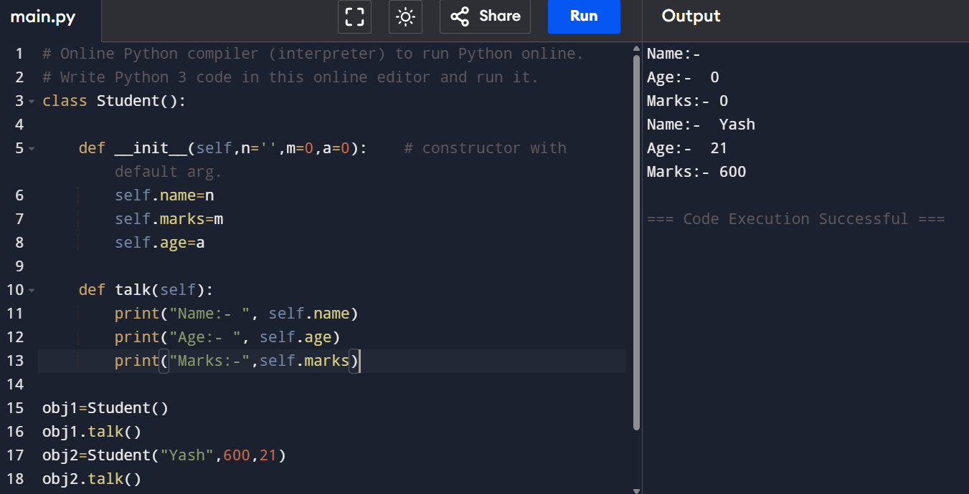

- In above case we passed, three arguments to student instance.
- Main duty of constructor is to initialize or store the beginning values into the instance variable.
- Constructor is called only once at the time of creating object.
- If 4-objects are created then constructor is called 4 –times.

Types of Variables:-
- Instance Variables
  - Its separate copy is created in every instance.
- Class/Static Variables
  - Single copy is available to all instances.

class Student(object):
cnt=0 #class variable
def __init__(self,n='',m=0,a=0):
self.name=n
self.marks=m
self.age=a

def talk(self):
print("Name:- ", self.name)
print("Age:- ", self.age)
print("Marks:-",self.marks)

@classmethod # built in decorator statement
def count(cls):
cls.cnt+=1

obj1=Student()
obj1.talk()
obj2=Student("Yash",600,21)
obj2.talk()
obj1.count()
obj2.count()
print("No of Objects", obj1.cnt)

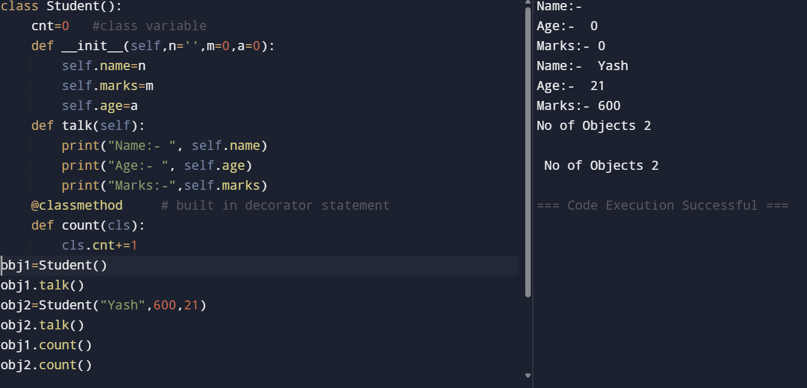

Class Method:-
- It use first parameter by default ‘cls’ with which we can access the class variable.
- Example:-

@classmethod # built in decorator statement
def count(cls):
cls.cnt+=1
- We can also have other parameters in the class method in addition to the ‘cls’ parameter.
- We can access the class variables from outside the class using class name. classname.variable…

class Student(object):
cnt=0 #class varaible
def __init__(self,n='',m=0,a=0):
Student.cnt+=1
print("Student:-",Student.cnt)
self.name=n
self.marks=m
self.age=a

def talk(self):
print("Name:- ", self.name)
print("Age:- ", self.age)
print("Marks:-",self.marks)

@classmethod # built in decorator statement
def count(cls):
print("No of Objects", cls.cnt)

obj1=Student()
obj1.talk()
obj2=Student("Yash",600,21)
obj2.talk()
obj2.count()
print("No of Objects", obj1.cnt)

Types of Methods:-
- Instance Methods
  - Accessor Methods
    - Access or read the data of variable
    - They do not modify the values/data of variable
    - Are also called getter method
    - Written in the form getXXX( )
  - Mutator Methods
    - Not only read but also modify them.
    - Also called setter method
    - Written in the form setXXX( )
- Class Methods
  - These methods act on class level.
  - It can act on class or static variable
  - These methods are written using @classmethod decorator
  - By default first parameter is cls.
  - These methods are generally called using classname.methodname()

- Static Methods
  - We required static methods when some processing is related to the class but does not need the class or its instances to perform any work.
  - Example, counting number of instances of class.
  - Static methods are written with @staticmethod decorator
  - These methods are generally called using classname.methodname()
  - Example:-
class Test:
c=0 #this is class/static variable

def __init__(self):
Test.c+=1
@staticmethod
def objCount():
print('No of objects are ',Test.c)

t1=Test()
t2=Test()
t3=Test()
t4=Test()
Test.objCount()

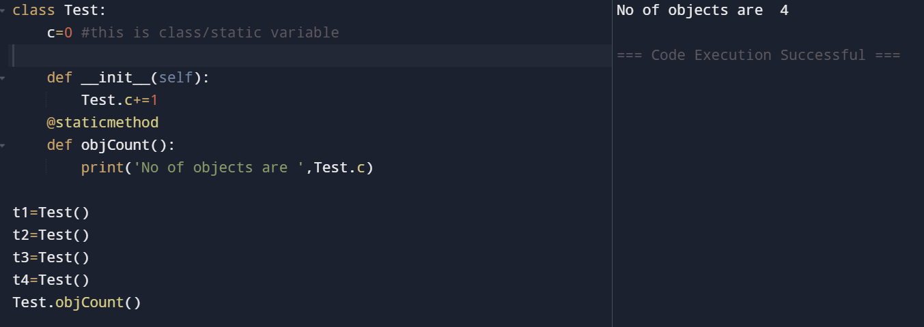

PRACTICAL 11
Part B (to be completed by students)

Object Oriented Programming, Class Object, self, __init__, instance variables and methods

- All the students are required to perform the given tasks in Jupyter Notebook
- Create a new notebook for each experiment. The filename should be RollNo_Name_Exp11)
- In the first cell, the student must write his/her Name, roll no and class in the form of comments
- Every program should be written in separate cells and in the given sequence
- After completing the experiment, download the notebook in pdf format. The filename should be RollNo_Name_Exp11.pdf).
Note: - To download as a PDF, go to File and choose Print Preview. This will open a new tab. Now, press Ctrl + P and opt to save as PDF.
OR
Download notebook as HTML and open downloaded html(webpage), press CTRL+P and opt to save as PDF.
- Upload the pdf on the web portal

